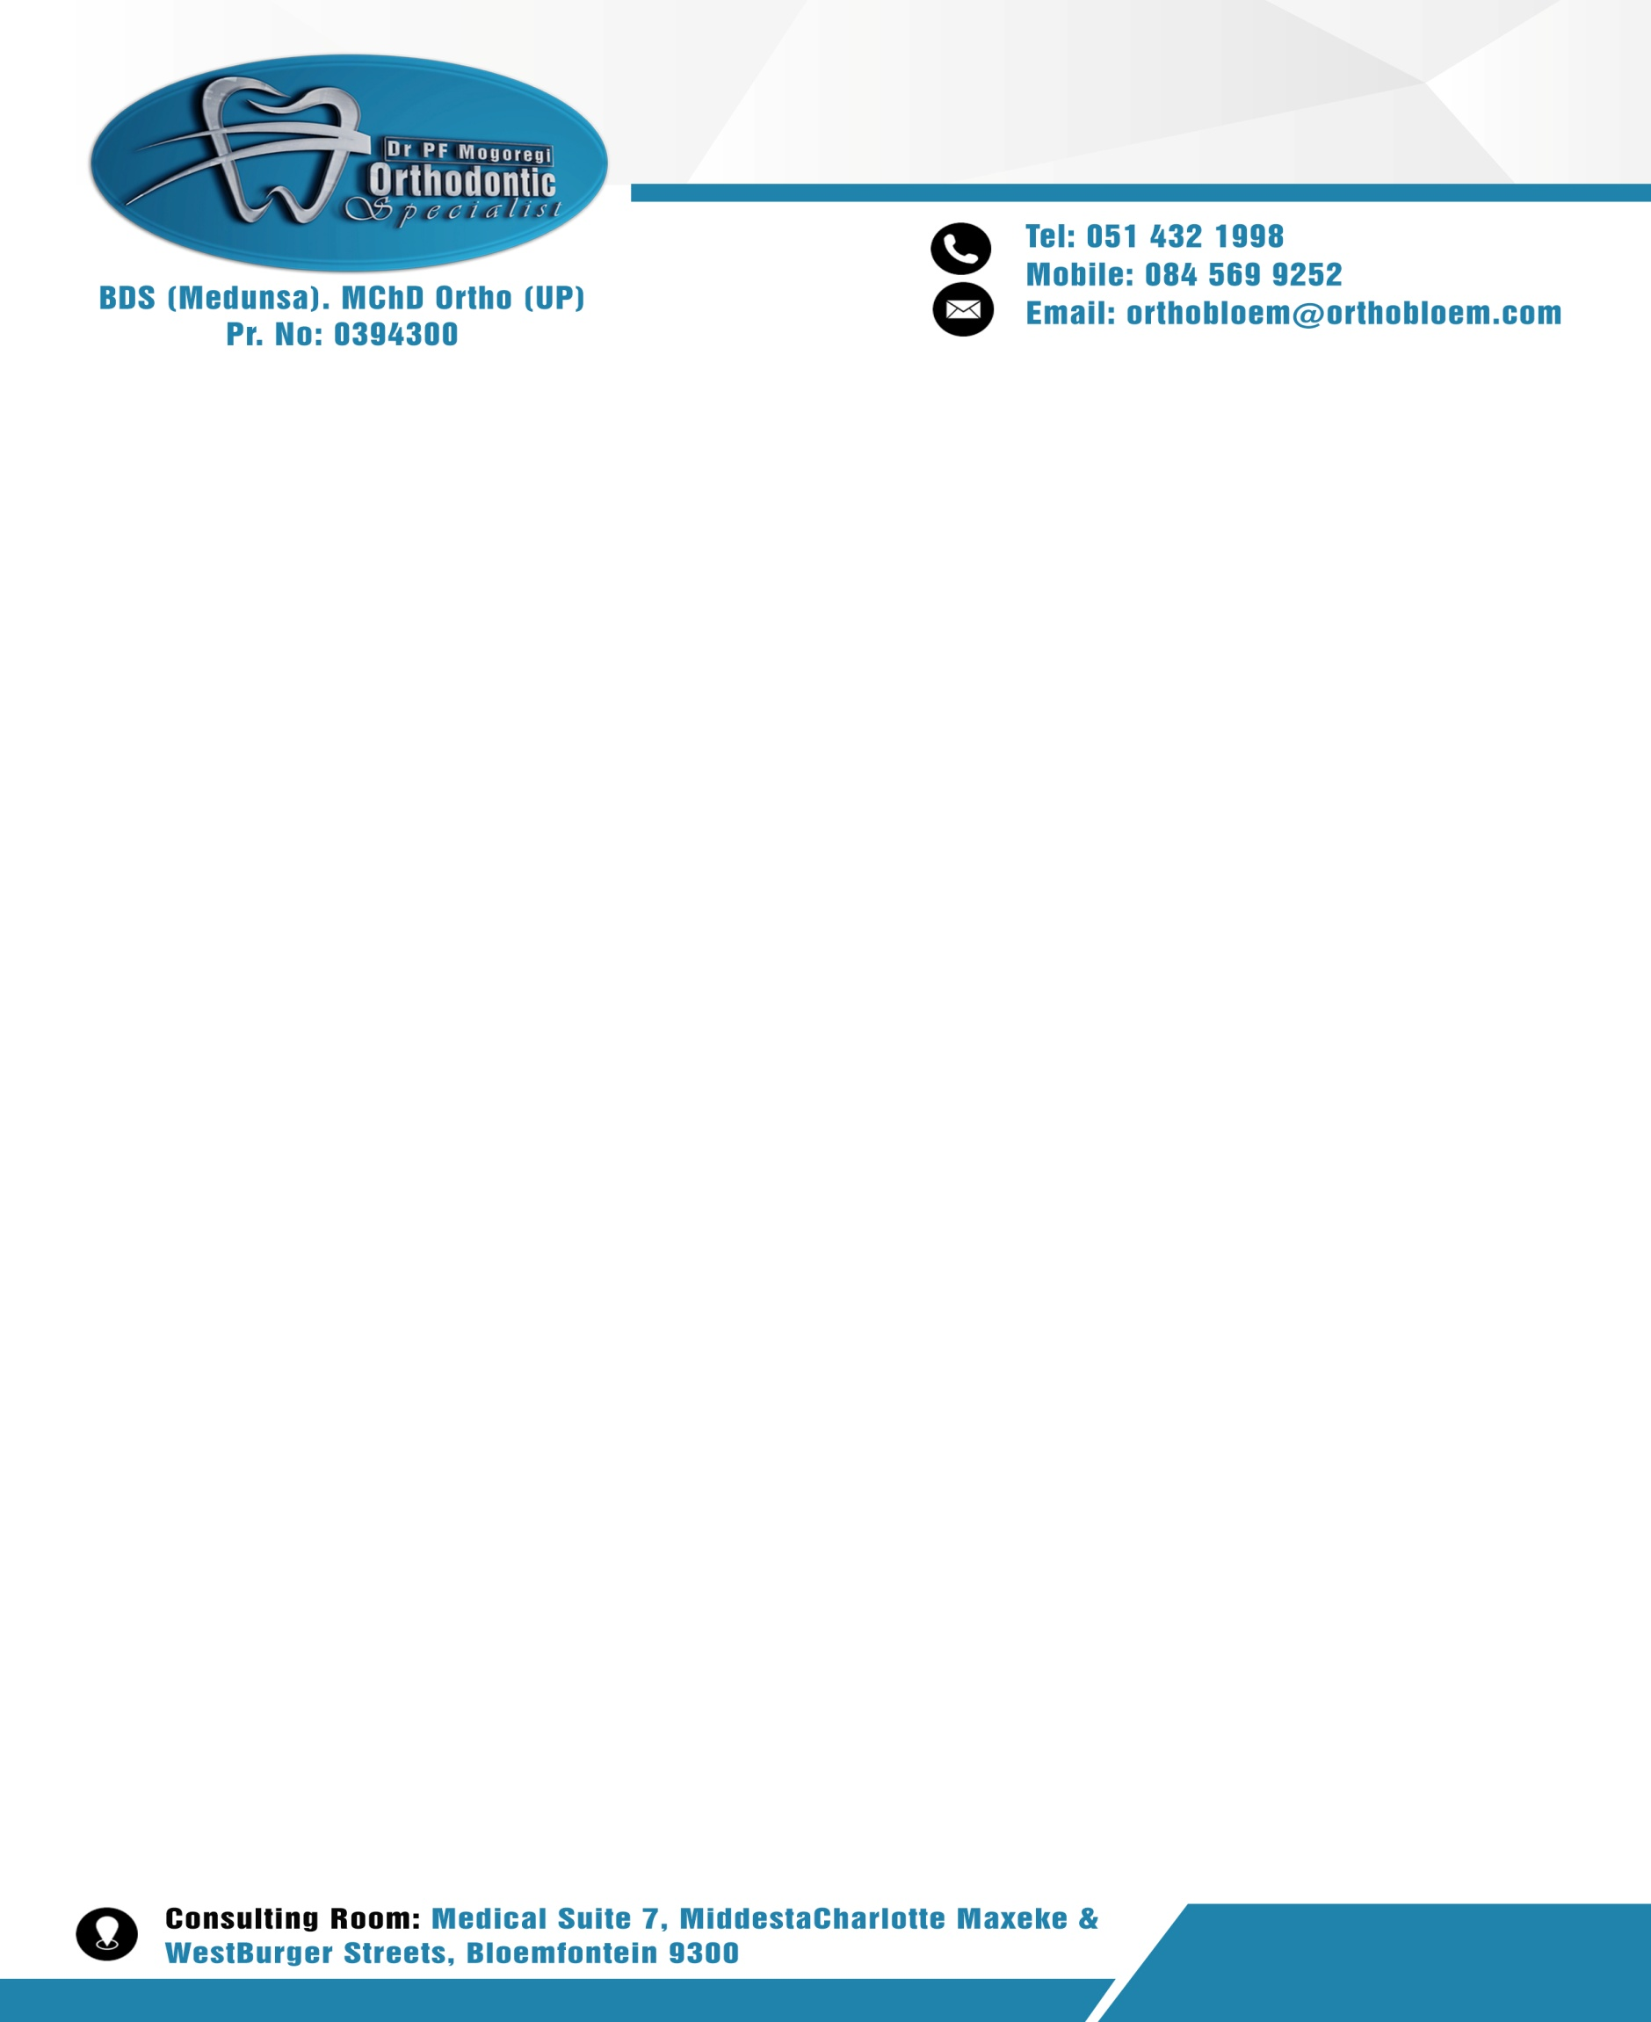

- PARTICULARS OF PATIENT:
SURNAME |  | DATE OF BIRTH
FULL NAMES |  | HOME LANGUAGE
MOBILE |  | MEDICAL AID
TEL(W) AND (H) |  | MEDICAL AID NO.
EMAIL |  | ID NUMBER
RESIDENTIAL ADDRESS |  | GENDER | MALE OR FEMALE
DENTIST |  | MEDICAL DOCTOR
REFERRED BY |  | SCHOOL

- PERSON RESPONSIBLE FOR ACCOUNT
SURNAME |  | TITLE
FULL NAMES |  | ID NUMBER
MOBILE |  | MEDICAL AID
TEL (W) AND (H) |  | MEDICAL AID NO
EMAIL |  | NEAREST RELATIVE
RESIDENTIAL ADDRESS |  | RELATIVE CONTACTS
OCCUPATION |  | MARITAL STATUS
EMPLOYER |  | RELATINSHIP TO PATIENT


